Supplementary Figure 1. Kaplan-Meier curve for cardiac perforation – Patients treated in non-CTS backup hospitals
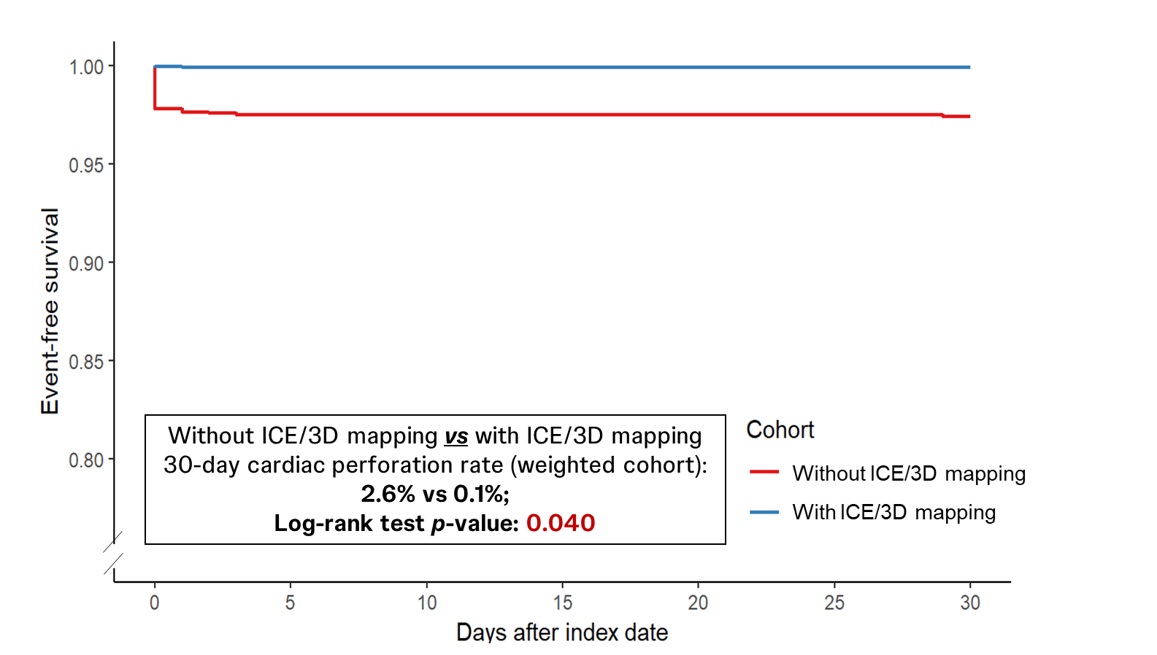

Supplementary Figure 2. Kaplan-Meier curve for death – Patients treated in non-CTS backup hospitals
